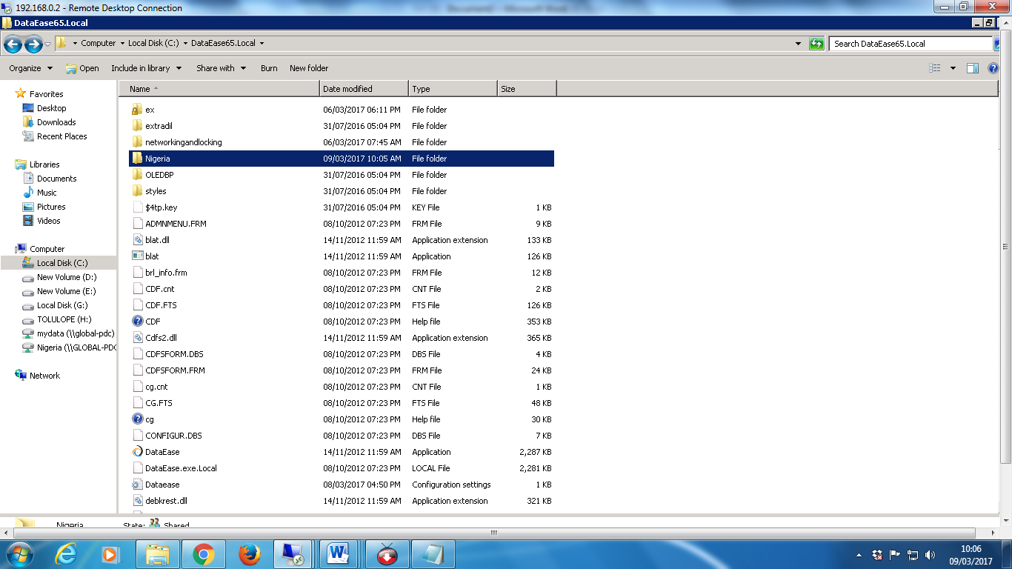
This image above is my dataease application install in C drive of the server 2008. I created a folder called ex copied configure.dat from Opportunicstic Locking and denetwork.ovl from networkingandlocking into the ex folder.
We have a folder that contains our database I called Nigeria. It’s inside dataease in c: drive and that’s the folder I mapped on the network for dataease users.

DENAME AND DEPATH IS SETS AS FOLLOWINGS
